ReTaM

Lab code reference table management tool

1. Introduction 1
2. Language & Login 2
3. Search & filter 4
4. Status of codes, Released code list 5
5. Analysis Overview screen. 6
6. Groupings 8
7. Download of the reference tables. 9
8. Domain Experts: additional functions 10
a) General information 10
b) Adding a new concept 11
c) Associating a LOINC code to a concept 12
d) Associating Specimen, Unit type and method 13
e) Workflow of concepts 15
f) Validating a new/modified concept 16
g) De-Validating a concept 17
h) Second validation 18
ANNEX 1: Proposition for the structure of the label in EN, FR, DU, GE 19

Introduction
The ReTaM lab code table management tool is a visual (and searchable) representation of the authentic source for laboratory codes.

It has been developed and is hosted by eHealth. The unique source for lab codes could not be realized but for the longstanding and unabated support for standardization by the FOD Volksgezondheid - SPF Santé Publique.

This authentic source is –wherever possible – based on LOINC. However, as for a number of common concepts multiple applicable LOINC codes exist, and for some others LOINC codes do not yet exist, choices have been made. Also a sequential numerical code (so-called Albert code) is attributed to each concept, so concepts without a preferred LOINC code can still be uniquely referenced.

In addition to visualizing the tables, this tool also allows domain experts to make suggestions relating to represented or missing concepts and to encourage collaborative working on the authentic source. To allow for these functions, three distinct user profiles exist.
- User: possibility to search and to make comments.
- Domain Expert: additionally: possibility to add or modify concepts and relations, make notes, validate concepts ready for publication according to his/her professional knowledge.
- System manager-Expert: additionally: possibility to prepare new release versions and modification in secondary tables.

Domain experts who are interested to collaborate to improve the quality of the authentic source, are welcome to contact the current System manager – Experts (cfr infra, contact)

Language & Login
Retam is a web-based tool, and can currently be accessed at:
https://www.vas.ehealth.fgov.be/webretam/retam/

Click top left on the language of your choice.
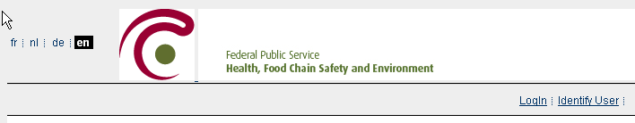

By default you start in a ‘user’ role. If you received login credentials (for experts and system managers), click on ‘Login’ at the right side to log in
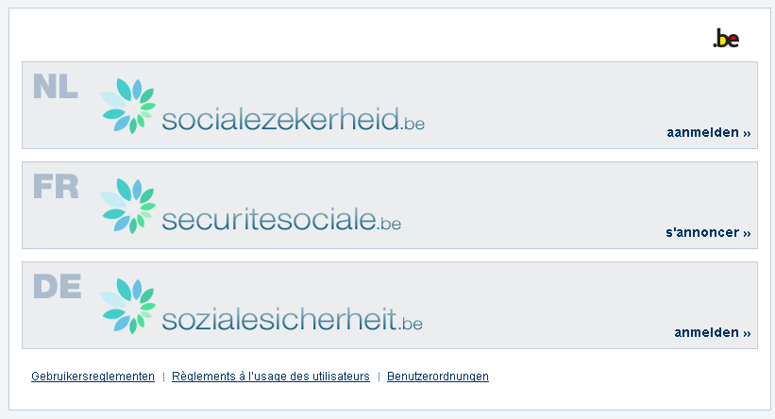
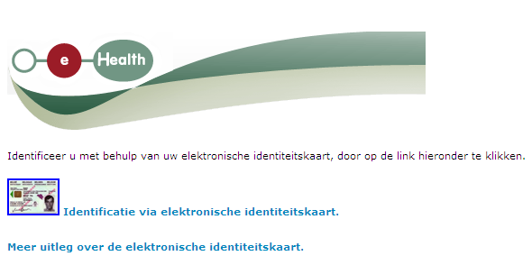

Allowed Functions according to user type:

Utilisateur anonyme | Expert | Super Expert
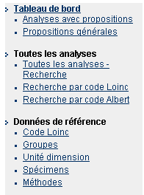 | 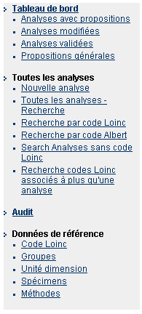 | 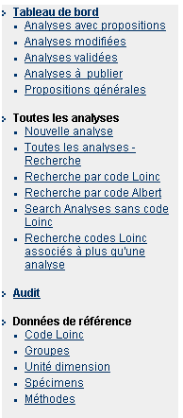

Search & filter

To search through the whole database (keeping in mind that not all currently present concepts will get validated), the easiest way to start is by clickling on ‘all analysis search’ in the left pane.

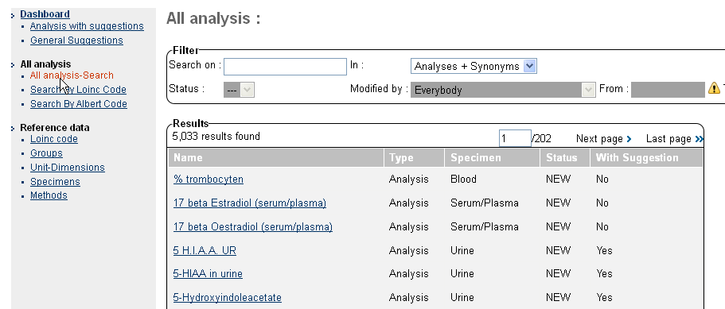

This makes the search fields appear, where you filter the output to the concepts you are interested in. By default, the tool will search in the structured name of the concept + synonyms in all languages.

It is equally possible to limit the search (eg to structured names only by choosing ‘Analysis’). :
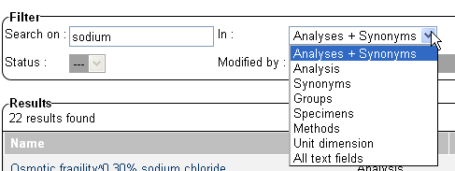

the option to search in ‘All text fields’ will equally search in specimen & group tables (cave: only for the currently selected language)

Clicking on a selected item will bring up the detailed overview for the selected concept.

Status of codes, Released code list

Not only the officially released concepts can be researched, also work in progress or deprecated concepts are standard accessible. To see a list of ONLY officially released codes, one has first to select ‘Analysis’ and in the status field ‘enabled’.

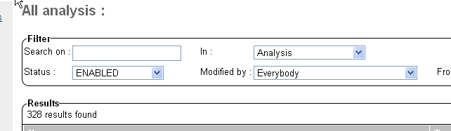

A short explanation of the important status indicators:
ENABLED
Active code (released or will be released in next release)

VALIDATED, VALIDATED_2ND, TO_RELEASE
Code is ready, different validation steps before official release

DISABLE, TO_DISABLE
Deprecated code, not to be used

NEW, MODIFIED
Work in progress, not ready, can possibly lead to a code to be released

In the search screen, the status of each code is indicated in the fourth column. Depending on your access level, you may see additional search possibilities for direct access to codes with a certain status in the left pane.

Always keep in mind that multiple languages and synonyms may cause one unique code to appear on multiple lines, this may appear confusing.

Analysis Overview screen.
For each defined concept in Retam, the most important information is combined on one screen. The whole concept is uniquely defined by the associated LOINC code or (if absent) its Albert code (see right middle)
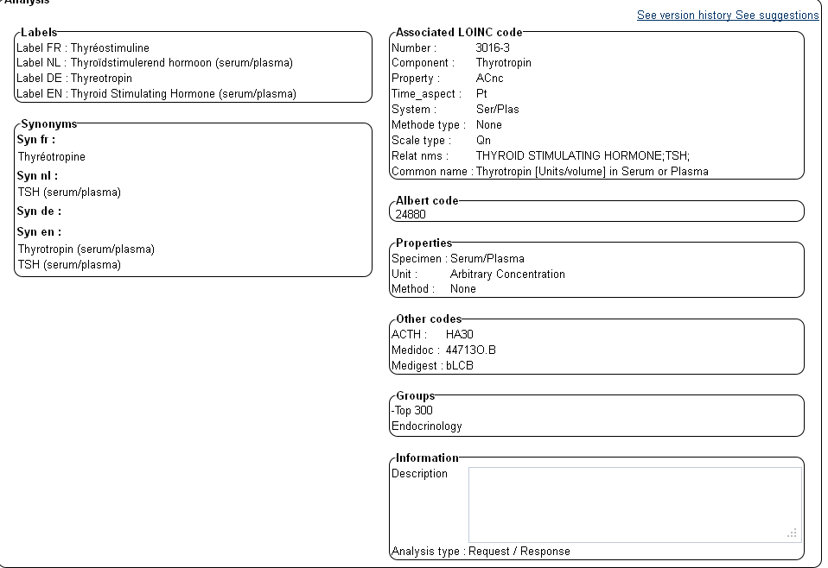

At the left side, the structured name in the different languages is shown, and possible synonyms.

At the right side, the associated specimen, unit type and method (if applicable) are shown. If applicable, backwards compatibility codes are shown below these properties.

Below these, arbitrary and non-binding ‘groupings’ are shown (see following chapter “groupings”).

Finally, bottom right, the analysis type is mentioned: either Request, Response, or Request /Response. The purpose of this analysis type is to provide the possibility to define concepts such as ‘protein electrophoresis’ which is used for requests only, results for this request will typically include albumin, gamma etc.

At the bottom of the screen, one has the possibility to add suggestions to the current concept, which will subsequently be visible to the experts managing the tables.

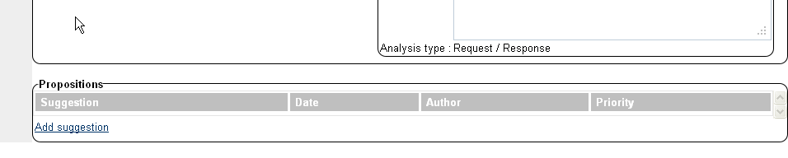

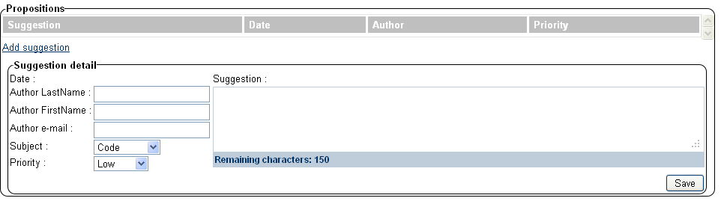

Groupings

Groupings (e.g. Haematology) can be used to facilitate searching and overviews of available concepts. A number of arbitrary groupings has been created to make navigation in the tool easier.

IMPORTANT: these groupings which may or may not be associated with concepts are merely destined to facilitate searching/filtering, and do not imply any completeness, structural consequence or recommendation. There are NO officially supported groupings for laboratory codes in the lab codes authentic source.

If you want to look at the codes currently associated to one of the groupings, choose “All analysis search” from the left pane, select “Groups” in the pull-down menu, leave the search field blank, and subsequently click right on “search”. This will bring up a list of existing groupings.

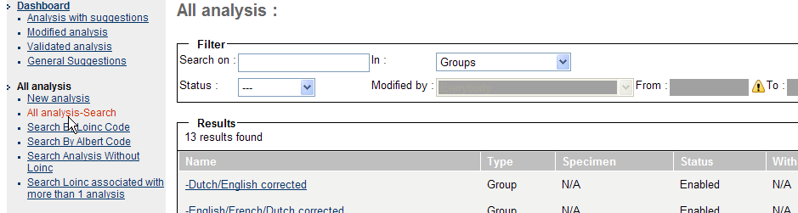

Clicking on one of the shown records will bring up a list of all concepts currently associated with that group. These groupings are non-binding and can overlap, so a concept can belong to several groups at once.

Now either right-click on an item and choose ‘open in new tab’ to keep the list and open an item, or use the back button on your browser to get back to the list after you open an item on the list.

IMPORTANT: in the status column you see the current status of the code, id est whether It is validated, released etc, as retam shows both released and work-in-progress codes.

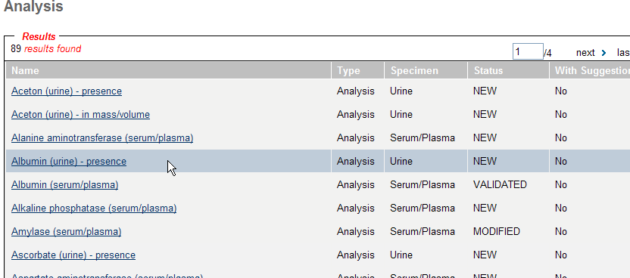

Download of the reference tables.
A download function for the tables to facilitate integration in existing applications is available *
*(currently both validated and non validated concepts )

Export structure:

1) methods (code + labels (different languages) + status + lastmodified date )
2) units (code + labels (different languages) + status + lastmodified )
3) specimen (code +labels (different languages) + status + lastmodified )
4) analysis:
Code Albert
Code LOINC
Label French
Label Dutch
Label German
Label English
Specimen
Unit
Method
Synonyms (separated by « / » or other)
Analysis type
Code ACTH
Code Medidoc
Code Medigest
LOINC component
LOINC property
LOINC Time_aspect
LOINC system
LOINC Methode type
LOINC Scale type
LOINC related names
LOINC Long common name
information
lastmodified date
status

5) groups: code, labels, status
6) analysis - groups : albert code, group code

Domain Experts: additional functions

General information

After logging in, the current profile is displayed top right
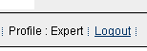

Domain Experts have access to a number of additional functions, visible in the left pane:
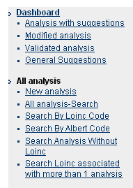

Retam contains both validated and work-in-progress analysis and analysis which were once linked in ACTH to LOINC.

To see the list of newly validated concepts, one has to chose from the list ‘to release analysis’ and ‘validated analysis’, in the dashboard left top.
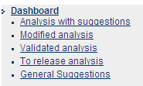

In the all-analysis search, click the status field and select ‘enabled’ to search/see a list of released codes

The basic concept of ReTaM for the creation of a new analysis is simple: Experts can add propositions (or modify existing ones (if they were not yet officially published)). If the expert considers the concept to be ready for publication and a LOINC code, specimen etc have been added, he/she can ‘validate’ the concept.

Once two different experts have ‘validated’ a concept, it is potentially ready for publication and can be added to a new release by the Expert-System managers.

Adding a new concept
A new concept can be initiated by clicking on ‘new analysis’ in the left pane. However, before initiating a new analysis, it is mandatory to do extensive searching of the ReTaM analysis and synonym tables, to be sure the desired concept is really new and worthwhile to add.
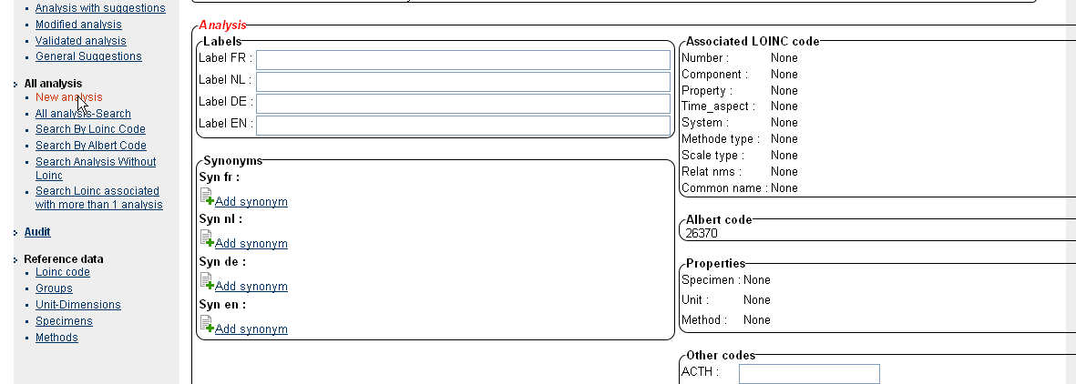

Subsequently, the labels for the different languages can be filled in. There are a number of syntactic rules which should be followed to ensure a standardized representation in the table. These are detailed in a separate document, please consult these rules and the provided examples before starting to add or modify concepts.

If you think searching for the newly created concept will be facilitated by adding one or more synonyms, you can add these. However you should only add synonyms for the appropriate language. If the synonym is language independent one should add it for the English language field only.

Associating a LOINC code to a concept

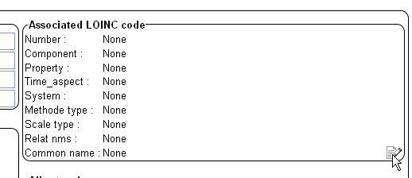
At the bottom right of the loinc code window, click on the notebook, this will open the loinc code search screen.

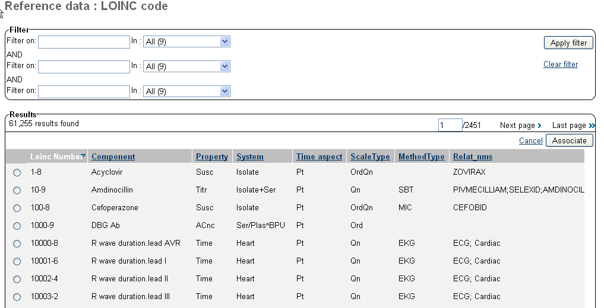

As with the analysis search, use the filter fields to limit your search (or you can choose to eg search only the long common name field).

As with the naming of the labels, certain rules have to be taken into account when considering associating a LOINC code. These are equally explained in the separate document (basically it boils down to selecting the least specific LOINC code for a given concept, unless a more specified version is necessitated (e.g. if a given analyte is frequently measured in Belgium using two very different methodologies yielding very different results making it effectively two different concepts this would warrant the usage of a more specific LOINC code accommodating for these differences.

When in doubt, it is better not to associate an inappropriate LOINC code and leave it open. Once the correct code (if found) is selected, click on “Associate” to link it to the new concept.

A LOINC code can only be associated once. If you try to associate it a second time, a warning will appear and action has to be taken to avoid double usage and resolve the possible conflicting items.
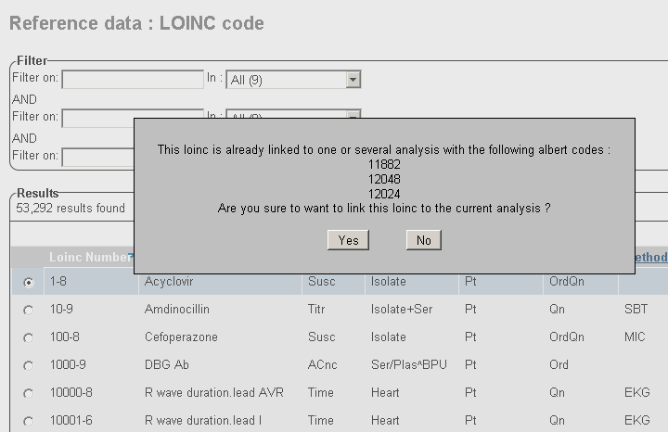

Associating Specimen, Unit type and method

A specimen and unit type should ALWAYS be added. As for the LOINC codes, click on the notebook to open the selection screens.
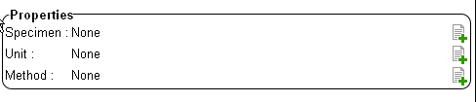

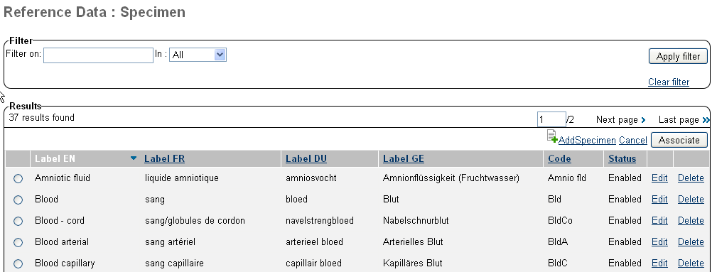

Select the correct specimen (eg Serum/Plasma) and click on “associate”.

A method should only be specified if this of real importance to define the concept. For most concepts, this is not the case and the method should be left blank.

Make sure appropriate groups are associated to the concept as well. Once a concept is validated it is no longer possible to associate groups or change items, before de-validating again.

Workflow of concepts

Initial Status | workflow | Description + final status
New | Delete | Supprime l’analyse de façon définitive
 | Validate 1 | Valide les données  Passe au statut « validate 1 »  Apparaît dans la liste « analyses validées »
Validate 1 | Cancel | Revient à l’état initial « new » ou « modified » ou « to desactivate » ou « to reenable »  Apparaît dans la liste « analyses modifiées »
 | Validate 2 | Valide une deuxième fois les données  Passe au statut « validate 2 »  Apparaît dans la liste « analyses à publier  »
Validate 2 | Cancel | Revient à l’état initial « new » ou « modified » ou « to desactivate » ou « to reenable »  Apparaît dans la liste « analyses modifiées »
 | Ask release | Passe au statut «To release »
To Release | Release | Passe au statut « Enabled »  Crée une nouvelle version.  Rend le delete impossible.
 | Cancel | Revient à l’état initial « new » ou « modified » ou « to desactivate » ou « to reenable »  Apparaît dans la liste « analyses modifiées »
Enabled | Ask disable | Passe au statut « To desactivate »  Apparaît dans la liste « analyses modifiées »
 | Modify | Passe au statut « modified »  Crée une nouvelle version
Modified | Rollback | Revient à la version pécédente  Annule les modifications
 | Validate 1 | Valide les modifications  Passe au statut « validate 1 »  Apparaît dans la liste « analyses validées »
To desactivate | Rollback | Revient à la version pécédente  Annule la demande de désactivation
 | Validate 1 | Valide la demande de désactivation  Passe au statut « validate 1 »  Apparaît dans la liste « analyses validées »
Disabled | Ask reenable | Passe au statut « To reenable »  Apparaît dans la liste « analyses modifiées »
« To reenable » | Rollback | Revient à la version pécédente (désactivée)  Annule la demande de d’activation
 | Validate 1 | Valide la demande d’activation  Passe au statut « validate 1 »  Apparaît dans la liste « analyses validées »

Validating a new/modified concept

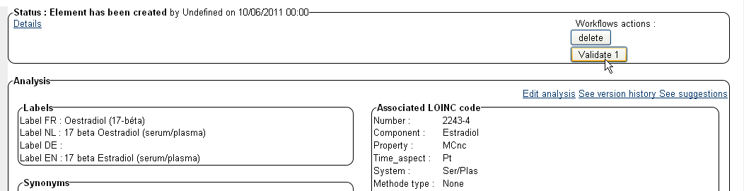

If minimally labels are specified in all relevant languages, specimen and unit type are specified and a LOINC code has been added whenever available for the concept at hand, the analysis can be validated (don’t forget to specify the request type).

At the top of the screen click on “validate 1” to validate the concept.

When in doubt, use ‘Save’ but do not validate, and specify doubts /remarks in the “Expert Zone” at the bottom of the analysis overview screen.
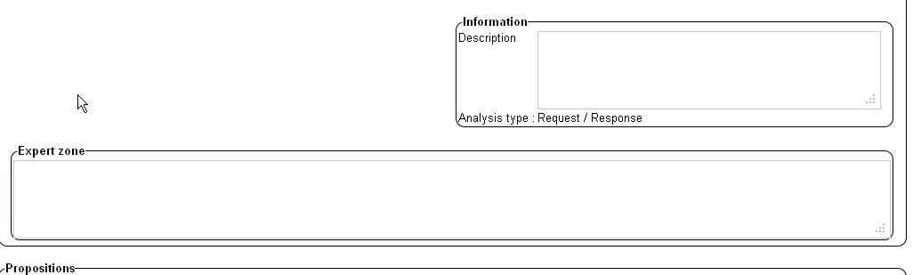

This “Expert Zone” field is for internal usage only.

Remarks which are intended for the broad public and which are helpful to understand the concept or to explain the difference with apparently closely related concepts can be specified in the “information” description field

De-Validating a concept
If inaccuracies or potential problems are perceived with a validated concept, a previous validation can be undone, by pressing “cancel”, top right.

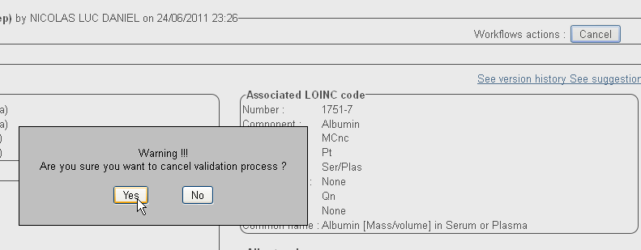

This will reinitiate the 2 step validation process.

Second validation

In the menu, click on “validated analysis” for a list of concepts which have been validated once, and are ready for final validation (or find them using the general “all analysis” search function).

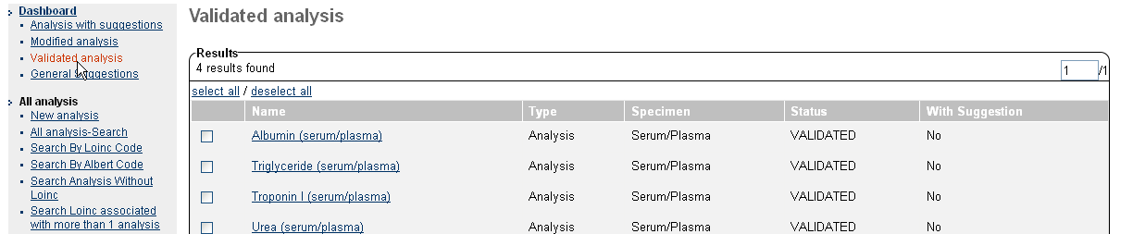

Before initiating a second validation (this can not be performed by the same expert which performed the first validation), one should verify whether all information defining the concept is correct:

- Have all labels been filled, and is the naming consistent with the guideline document?
- Are synonyms relevant and added to the correct language field(s)
- Has a LOINC code been specified?
- Is it the right LOINC code or is there a better one?
- Has the correct specimen been added?
- Has the correct unit type been added?
- Was a method necessary?

When in doubt, use the Expert Zone field, and DO NOT choose the second validation, as this is the final sign for declaring this analysis ready for publication.

ANNEX 1: Proposition for the structure of the label in EN, FR, DU, GE
(examples in English)

Component : part of component (specimen type) – extra information_1 – extra information_2 – extra information_3 - …

- Component
is what you are measuring in the lab in one process : this can be Sodium or measles antibodies or hemoglobin or …
Some requests/measurements generate more than one result. In this case we put the lab process first, followed by a “:” , followed by the real component.
e.g.
White blood cell differentiation: neutrophils
Protein electrophoresis: albumine
Protein electrophoresis: conclusion
Alcaline phosphatase iso-enzymes: bone.
Attention ! dynamic tests are not of this type: for a glucose tolerance test or a glucose profile we always measure glucose in the lab but on different specimens in different circumstances (see below)

- Extra information can be of any kind (order to be determined ???).
Attention ! Only use extra information if you want to make a distinction between two or more variants of the same component e.g. no need to add extra information for
Aspartate aminotransferase (serum/plasma).

  - Specification of the sampling time
Gentamicin (serum/plasma) – peak
  - Method specification
Erythrocytes (urine) – automated count
Erythrocytes (urine) – manual count
  - Dimension specification
White blood cell differentiation: neutrophils (blood) – in #/volume – automated count
White blood cell differentiation: neutrophils (blood) – in % – automated count
Copper (blood)– in mass/volume
Copper (blood) – in moles/volume
  - Add calculated or measured if both are possible
Low density lipoprotein cholesterol (serum/plasma) – measured
Low density lipoprotein cholesterol (serum/plasma) – calculated
  - Qualitative and quantitative results
Cytomegalovirus IgM (serum) – presence
Cytomegalovirus IgM (serum) – in titre
Cytomegalovirus IgM (serum) – in units/volume
  - Components part of dynamic tests:
Growth hormone (serum/plasma) – in insulin tolerance test – 120 min
Glucose (serum/plasma) – in day profile – 10:00 h

Use of abbreviations

Always use the full name in the labels. Put the current abbreviations in the synonyms (without “.” ).
Exceptions only for Antigen (Ag) and Antibodies (Ab).
If the nature of the Ab is known add this instead of Ab e.g. Hepatitis A virus IgM

Preferred labels / conventions
- For all extra information (methods, units, …) use terminology comparable to the one used in LOINC (especially in the English language)
- For LOINC-codes with ‘presence’ in the long common name and scaletype=ordinal, we use ‘qualitatif’ in French and ‘kwalitatief’ in Dutch.
- Some tests were historically reported without specifying the method. Later , several methods were introduced and codes for this specific methods were assigned. To be able to report the historical data we will add to the label ‘- method not specified’ and also put this in the method-field.
- Make a list of allowed terminology: conclusion, comment, discussion ???
- For now bloodgasses will be coded for ‘arterial blood’, ‘venous blood’ and ‘blood’
- Analyses on urines will be coded (if applicable) for ‘urine sample’, ‘urine 24 h collection’ and ‘urine XXX h collection’

Examples of long common name LOINC

2862-1 | Albumin [Mass/volume] in Serum or Plasma by Electrophoresis
15547-3 | Asparagus IgE Ab RAST class in Serum
7099-5 | Asparagus IgE Ab [Units/volume] in Serum
12208-5 | Eosinophils/100 leukocytes in Cerebral spinal fluid by Manual count
711-2 | Eosinophils [#/volume] in Blood by Automated count

Would become in Albert:

Protein electrophoresis: Albumin (serum/plasma) – in mass/volume
Asparagus IgE (serum) – presence
Asparagus IgE (serum) – in units/volume
White blood cell differentiation: eosinophils (cerebral spinal fluid) – in % - manual count
White blood cell differentiation: eosinophils (blood) – in #/volume – automated count

